Nepal College of Information Technology
Balkumari Lalitpur
Unit Test Spring Semester 2008

Engineering Math-II
Year: 2008 FM: 60
Sem: II PM: 30
Program BE Time: 2hrs

Attempt all the questions:

1. Solve the differential equation
a) 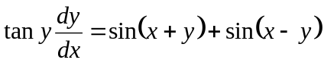 7
b) 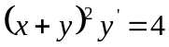 8

2. a) Define integrating factor and solve
(x + y) (dx - dy) = dx + dy 2+6
b) Solve 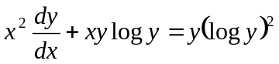 7

3. Solve the differential equation
a) y" + y' = x² + 4 7
b) y" + 8y' + 16y = 64 cosh 4x 8

4 a) Solve the initial value problems
y" + 9y = 6 cos3x, y(0) = 1. y' (0) = 0 8

OR
Solve : y" + 2y' + y = 4e^{-x} logx

b) Solve : y" = -9y by power series method 7

END

Nepal College of Information Technology
Balkumari Lalitpur
Unit Test Spring Semester 2008

Engineering Math-II
Year: 2008 FM: 60
Sem: II PM: 30
Program BE Time: 2hrs

Attempt all the questions:

1. Solve the differential equation
a) 7
b) 8

2. a) Define integrating factor and solve
(x + y) (dx - dy) = dx + dy 2+6
b) Solve 7

3. Solve the differential equation
a) y" + y' = x² + 4 7
b) y" + 8y' + 16y = 64 cosh 4x 8

4 a) Solve the initial value problems
y" + 9y = 6 cos3x, y(0) = 1. y' (0) = 0 8

OR
Solve : y" + 2y' + y = 4e^{-x} logx

b) Solve : y" = -9y by power series method 7

END

